1ST INTERNATIONAL KARL STORZ OTOLOGY WEBINAR
Endoscopic & Exoscopic Treatment of otological diseases:
How new visualization technologies can improve clinical outcomes

Thursday, August 26th 2021 | 5:00 - 6:30 pm CET | 11:00 - 11:30 am EST | 8:00 - 9:30 am PST |

OPENING: 8:00 – 8:05 AM PST

Welcome to the 1st international KARL STORZ otology webinar

Moderator: Prof. Marco Caversaccio (Bern, Switzerland)
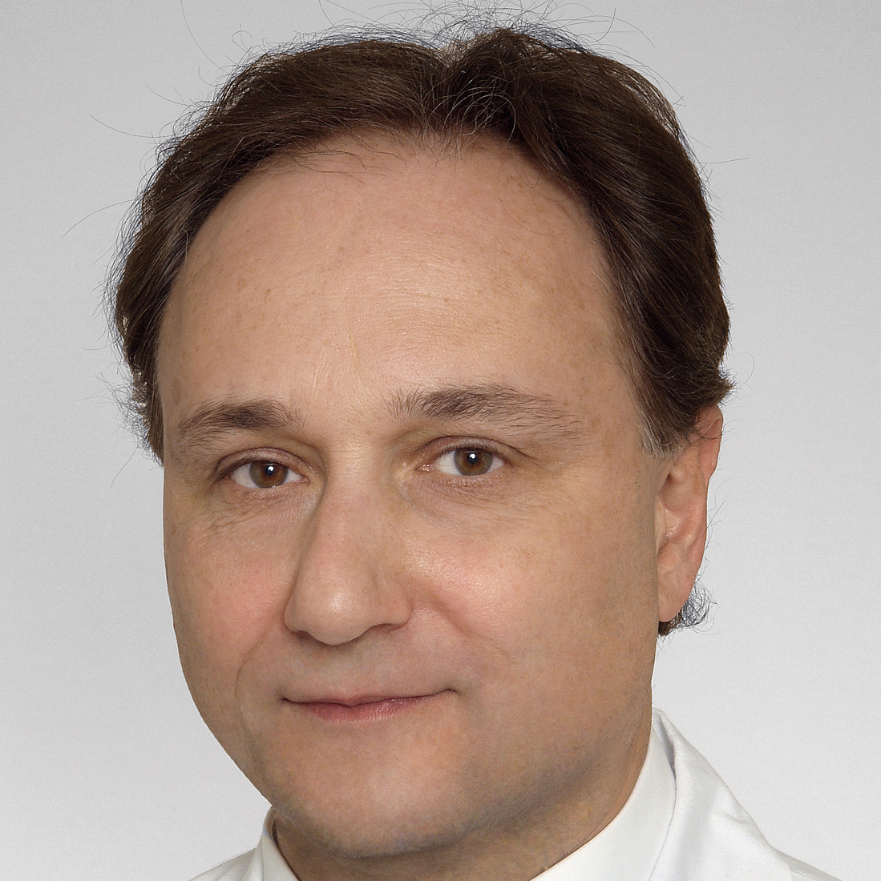
Prof. Caversaccio is an experienced ENT specialist who focuses on tumors in the head and neck - such as the preservation of the voice during laryngectomy. His findings in computer-assisted surgery made him internationally known in the professional world. email@email.com | Insel Hospital

PRESENTATION 1: 8:05 – 8:25 AM PST

VITOM 3D IN EXOSCOPIC AND ENDOSCOPIC EAR SURGERY: the benefits of a combined approach

Presenter: Prof. Daniele Marchioni (Verona, Italy)

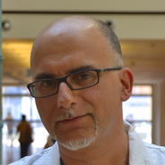
Prof. Marchioni is specialized in microscopic and exclusive endoscopic surgery in the districts of the skull base and ear, the head and neck cancer surgery He is a founding member of ‘IWGEES (International Working Group for Endoscopic Surgery Ear). Prof. Marchioni has published the first international book on the endoscopic treatment of ear disease and acoustic neuromas and lateral skull base. email@email.com | University of Verona

PRESENTATION 2 8:25 – 8:45 AM PST

PEDIATRIC ENDOSCOPIC EAR SURGERY

Presenter: Stephen R. Hoff, MD, FACS, FAAP (Chicago, Il, USA)

Dr. Hoff is a recognized leader in endoscopic ear surgery. He specializes in pediatric ENT needs, including ear tube placement and tonsillectomies and works to improve hearing and cosmetic outcomes for children born with malformed ears. He has active research projects related to endoscopic ear surgery, cochlear implantation, and 3D printing for pediatric ear reconstruction and otologic surgery. SHoff@luriechildrens.org | Lurie Children's Surgical Foundation

PRESENTATION 3: 8:45 – 9:05 AM PST

ENDOSCOPIC EAR SURGERY: CHALLENGING CASES

Presenter: Brandon Isaacson, MD, FACS. (Dallas, TX, USA)

Brandon Isaacson, M.D., is a Professor in the Department of Otolaryngology-Head and Neck Surgery and serves as Co-Director of UT Southwestern's Comprehensive Skull Base Program. Dr. Isaacson also chairs the Otolaryngology Resident Selection Committee. Brandon.Isaacson@UTSouthwestern.edu | Southwestern Medical Center

DISCUSSION, live Q&A: 9:05 – 9:25 AM PST

FUTURE OF ENDOSCOPIC EAR SURGERY, questions from the audience

Moderator: Prof. Caversaccio (Bern, Switzerland)
Panelists: Prof. Marchioni (Verona, Italy)
Panelists: Stephen R. Hoff, MD, FACS, FAAP (Chicago, Il, USA)

Panelists: Brandon Isaacson, M.D., F.A.C.S. (Dallas, TX, USA)

CLOSING: 9:25 – 9:30 AM PST
Closing summary, on-demand access information
Moderator: Prof. Caversaccio (Bern, Switzerland)

